E-retail factors for customer activation and retention: A case study from Indian e-commerce customers

1.Problem Definition:
Many companies think that marketing is all about selling of products and how the company will increase its profitability in the market share and not considering after sales service to be able to know whether the customers are satisfied with the products are able to use it. The main problem is ‘what kind of strategies is expected from telecommunication industries to be able to retain their customers?’ Five major factors that contributed to the success of an e-commerce store have been identified as: service quality, system quality, information quality, trust and net benefit.

Attribute Information:
- 'Gender of respondent', 'How old are you?',
- 'Which city do you shop online from?',
- 'What is the Pin Code of where you shop online from?',
- 'Since How Long You are Shopping Online ?',
- 'How many times you have made an online purchase in the past ?’
- 'How do you access the internet while shopping on-line?',
- 'Which device do you use to access the online shopping?',
- 'What is the screen size of your mobile device?',
- 'What is the operating system (OS) of your device?',
- 'What browser do you run on your device to access the website?',
- 'Which channel did you follow to arrive at your favorite online store for the first time?',
- 'After first visit, how do you reach the online retail store?',
- 'How much time do you explore the e- retail store before making a purchase decision?',
- 'What is your preferred payment Option?',
- 'How frequently do you abandon (selecting an items and leaving without making payment) your shopping cart?',
- 'Why did you abandon the “Bag”, “Shopping Cart”?',
- 'The content on the website must be easy to read and understand',
- 'Information on similar product to the one highlighted is important for product comparison',
- 'Complete information on listed seller and product being offered is important for purchase decision.',
- 'All relevant information on listed products must be stated clearly',
- 'Ease of navigation in website', 'Loading and processing speed',
- 'User friendly Interface of the website', 'Convenient Payment methods',
- 'Trust that the online retail store will fulfill its part of the transaction at the stipulated time',
- 'Empathy (readiness to assist with queries) towards the customers',
- 'Being able to guarantee the privacy of the customer',
- 'Responsiveness, availability of several communication channels (email, online rep, twitter, phone etc.)',
- 'Online shopping gives monetary benefit and discounts',
- 'Enjoyment is derived from shopping online',
- 'Shopping online is convenient and flexible',
- 'Return and replacement policy of the e-tailer is important for purchase decision',
- 'Gaining access to loyalty programs is a benefit of shopping online,
- 'Displaying quality Information on the website improves satisfaction of customers',
- 'User derive satisfaction while shopping on a good quality website or application',
- 'Net Benefit derived from shopping online can lead to users satisfaction',
- 'User satisfaction cannot exist without trust',
- 'Offering a wide variety of listed product in several category',
- 'Provision of complete and relevant product information',
- 'Monetary savings',
- 'The Convenience of patronizing the online retailer',
- 'Shopping on the website gives you the sense of adventure',
- 'Shopping on your preferred e-tailer enhances your social status',
- 'You feel gratification shopping on your favorite e-tailer',
- 'Shopping on the website helps you fulfill certain roles',
- 'Getting value for money spent',
- 'From the following, tick any (or all) of the online retailers you have shopped from;',
- 'Easy to use website or application',
- 'Visual appealing web-page layout', 'Wild variety of product on offer',
- 'Complete, relevant description information of products',
- 'Fast loading website speed of website and application',
- 'Reliability of the website or application',
- 'Quickness to complete purchase',
- 'Availability of several payment options', 'Speedy order delivery',
- 'Privacy of customers’ information',
- 'Security of customer financial information',
- 'Perceived Trustworthiness',
- 'Presence of online assistance through multi-channel',
- 'Longer time to get logged in (promotion, sales period)',
- 'Longer time in displaying graphics and photos (promotion, sales period)',
- 'Late declaration of price (promotion, sales period)',
- 'Longer page loading time (promotion, sales period)',
- 'Limited mode of payment on most products (promotion, sales period)',
- 'Longer delivery period', 'Change in website/Application design',
- 'Frequent disruption when moving from one page to another',
- 'Website is as efficient as before',
- 'Which of the Indian online retailer would you recommend to a friend?'].

2. Data Analysis:
Data analysis is the process of collecting, modeling, and analyzing data to extract insights that support decision-making. There are several methods and techniques to perform analysis depending on the industry and the aim of the analysis.
In this E-retail factors for customer activation and retention: A case study from Indian e-commerce customer’s project here target variable is which of the Indian online retailer would you recommend to a friend? Is the target variable.
In this project only ‘What is the Pin Code of where you shop online from’ is only one column integer value are present and another all the columns are object values are present.

DataSet:
Classification analysis is a data analysis task within data-mining, that identifies and assigns categories to a collection of data to allow for more accurate analysis. The classification method makes use of mathematical techniques such as decision trees, linear programming, neural network and statistics.
Classification analysis can be used to question, make a decision, or predict behavior through the use of an algorithm. It works by developing a set of training data which contains a certain set of attributes as well as the likely outcome. The job of the classification algorithm is to discover how that set of attributes reaches its conclusion.
There are two steps in the construction of a classification model.
- Learning Step – this is where different algorithms are used to build a classifier by making the model learn using the training set available. The model has to be trained for the prediction of accurate results.
- Classification Step: this is where the model used to predict class labels, tests the constructed model on test data. Which in turn estimates the accuracy of the classification rules.
Types of classification model:
- Logistic Regression
- Naïve Bayes
- Stochastic Gradient Descent
- K-Nearest Neighbours
- Decision Tree
- Random Forest
- Support Vector Machine

3.EDA :
Exploratory Data Analysis, or EDA, is an important step in any Data Analysis or Data Science project. EDA is the process of investigating the dataset to discover patterns, and anomalies (outliers), and form hypotheses based on our understanding of the dataset.
EDA involves generating summary statistics for numerical data in the dataset and creating various graphical representations to understand the data better. In this article, we will understand EDA with the help of an example dataset. We will use Python language (Pandas library) for this purpose.

Importing libraries
We will start by importing the libraries we will require for performing EDA. These include NumPy, Pandas, Matplotlib, and Seaborn.
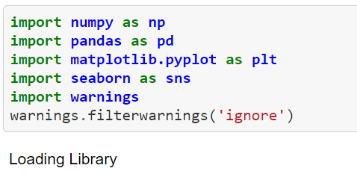

Reading data:
We will now read the data from a CSV file into a Pandas DataFrame.
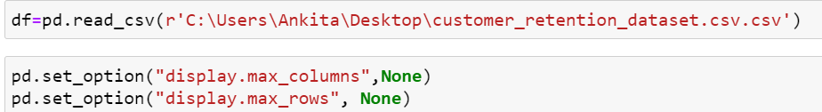

Then need to read and load customer dataset. And Then this below code is use for display all the columns in dataset.
Let us have a look at how our dataset looks like using df.head(). The output should look like this:
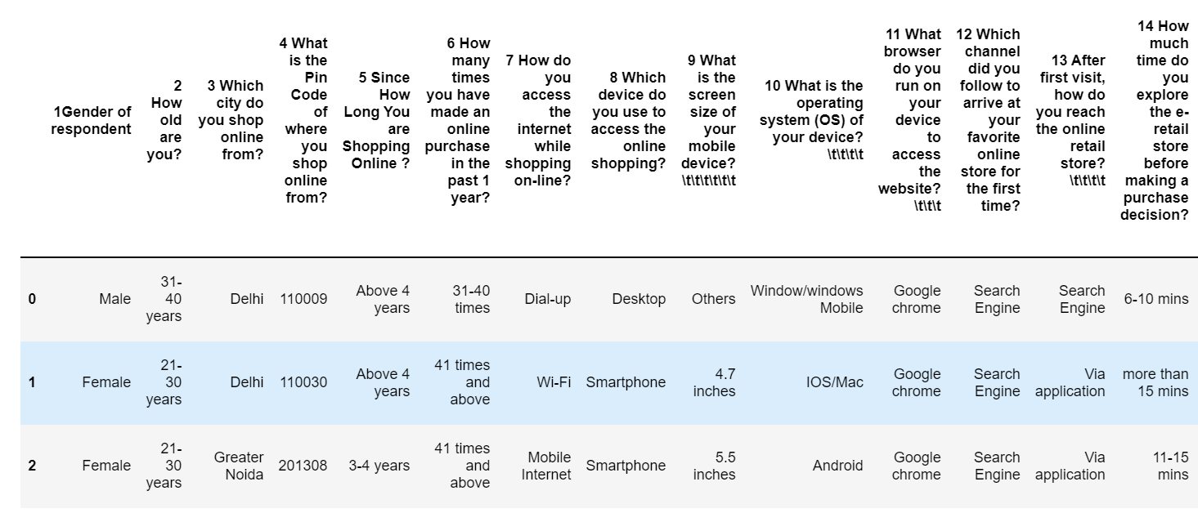

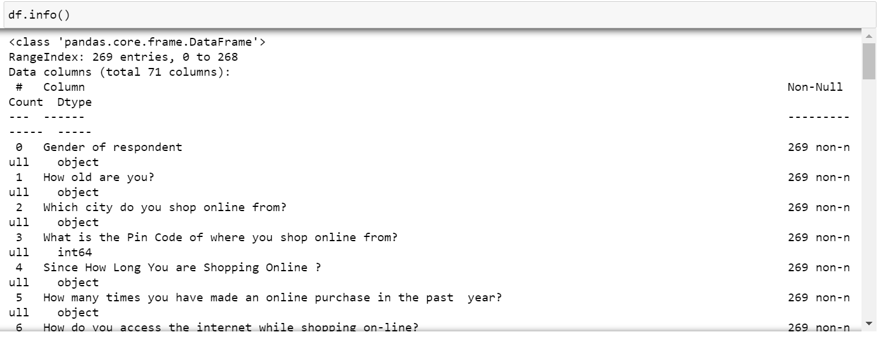

In above using df.info() is used to get the information all the columns in dataset and its data types. In above dataset there are 71.

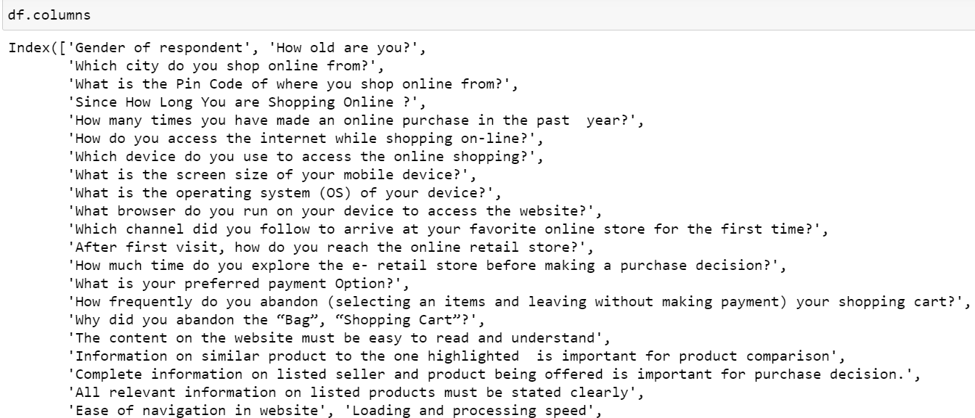

In above df.colums is use to get all the column names in dataset.

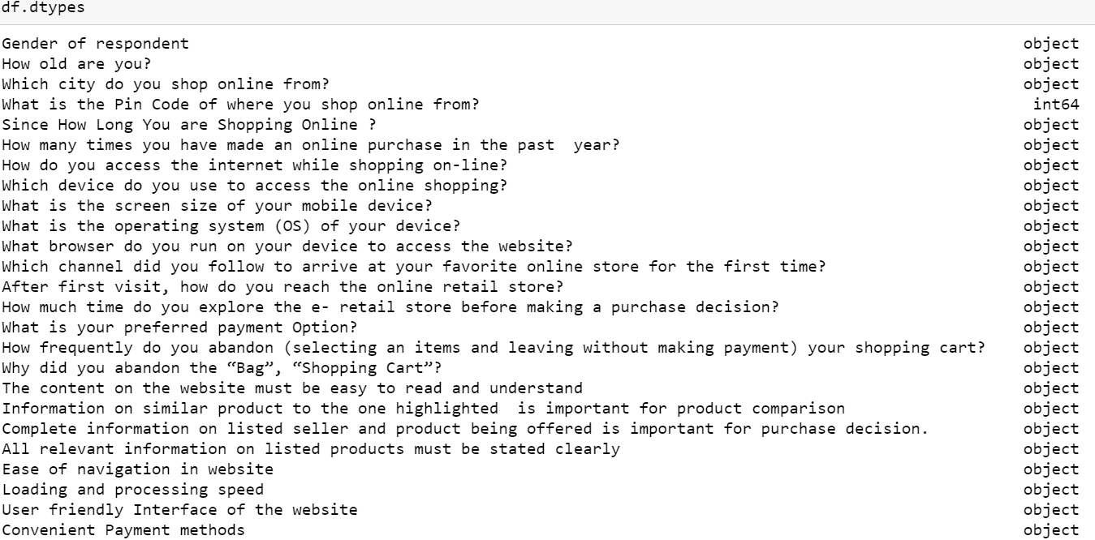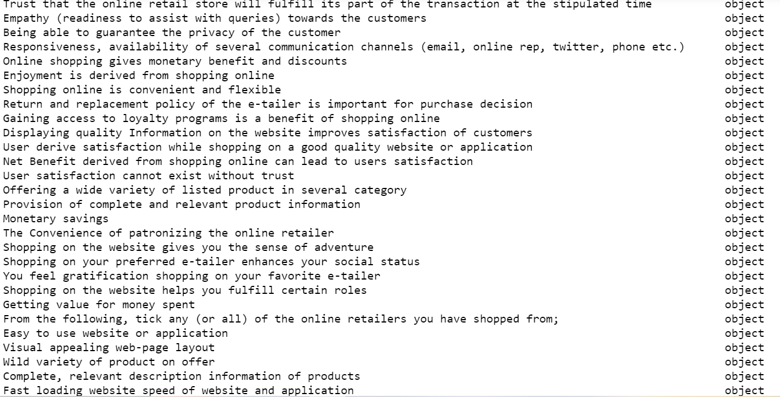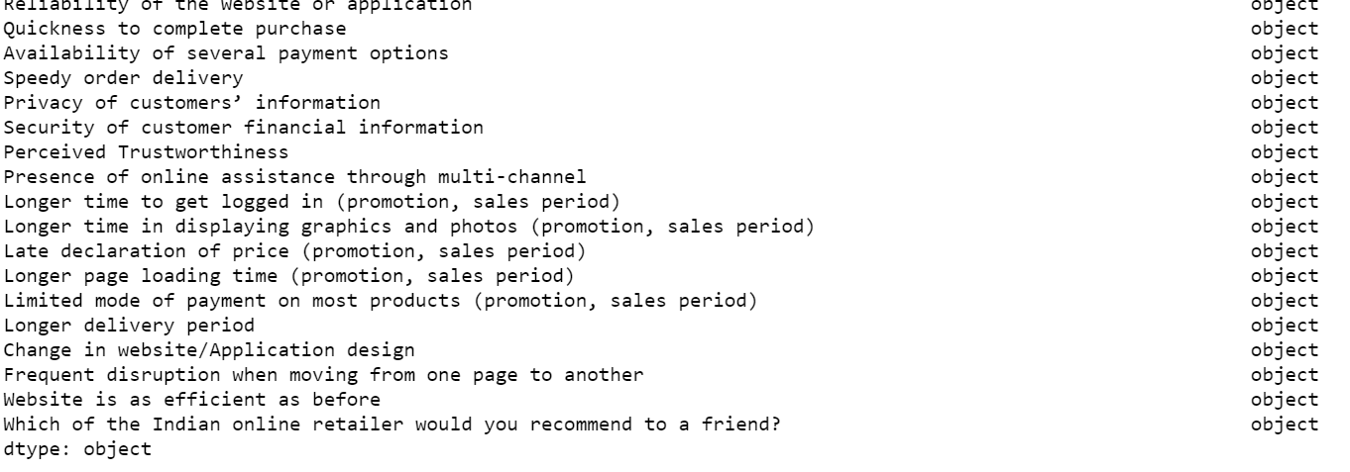

In above code df.dtypes is used to check the data types of all the column In above dataset all the values are object only What is the Pin Code of
where you shop online from? Is numeric value in dataset. object means
categorical value are present so convert need convert into numeric.
4. Pre-Processing Pipeline:

Looking at the shape, we see that we now have half of the data point than original data and the same number of features. Before processing and cleaning manually, let’s do some general data processing steps first:
- Remove features associated with >85% missing values
- Remove constant features
- Remove duplicates features
- Remove duplicate rows
- Remove highly collinear features.

- Remove features associated with 90% missing values: In the code below I first use pandas’ built-in method ‘isnull()’ to find the rows associated with missing values. Then I sum them up to get the count for each feature. Finally, I sort the features according to the number of missing values and create a data frame for further analysis.

- Remove constant features: At this step, we remove features that have a single unique value. A feature associated with one unique value does not help the model to generalize well since it’s variance is zero. A tree-based model cannot take advantage of these type of features since the model can not split these features.

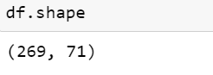
Check the how much Columns and rows present in dataset using df.shape() is use to check the rows and columns count in this above dataset there are 269 rows and 71 columns are present.

Alright, let’s get started with the typical data processing:
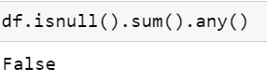

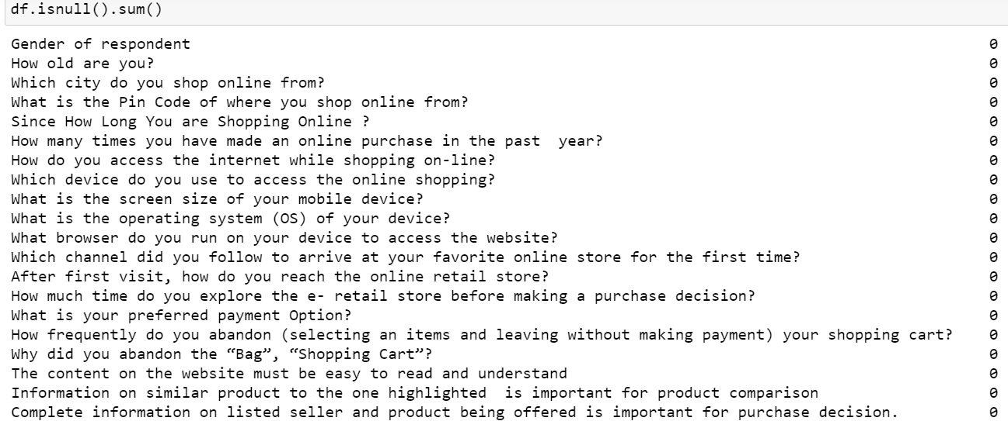

Check the how much missing values present in dataset using df.isnull() is use to check the missing values in dataset in this dataset there are no missing values are present.

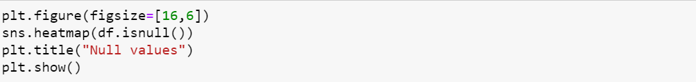
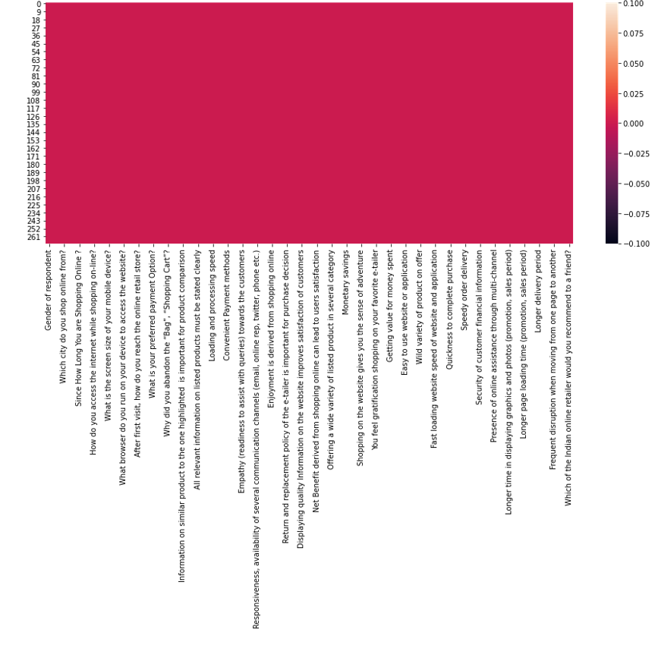
Heat map shows the no null Values are present in dataset.

Graphical representation

We will start with Univariate Analysis. We will be using a bar graph for this purpose.
Univarient Analysis:
Univariate analysis explores each variable in a data set, separately. It looks at the range of values, as well as the central tendency of the values. It describes the pattern of response to the variable. It describes each variable on its own.

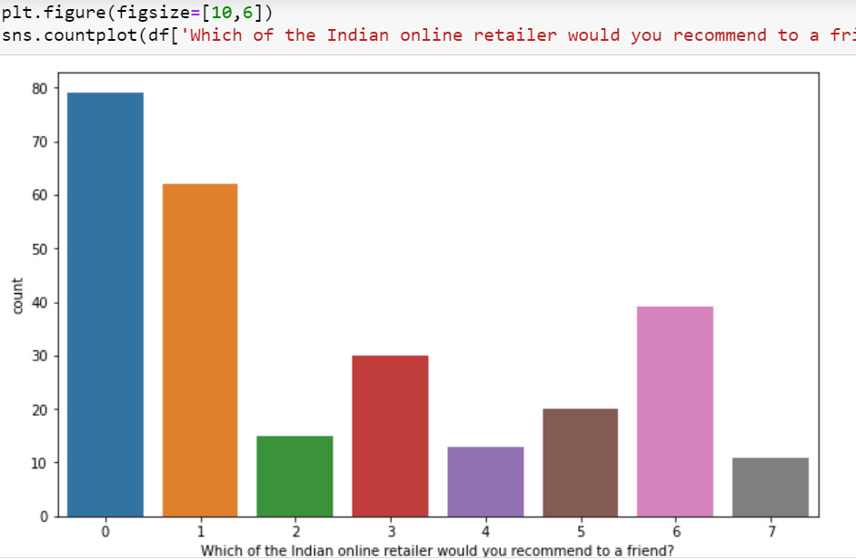

Univarient analysis of Which of the Indian online retailer would you recommend to a friend?' column.
Here above is target variable class is imbalanced so need to balance this class using SMOTE Oversampling.

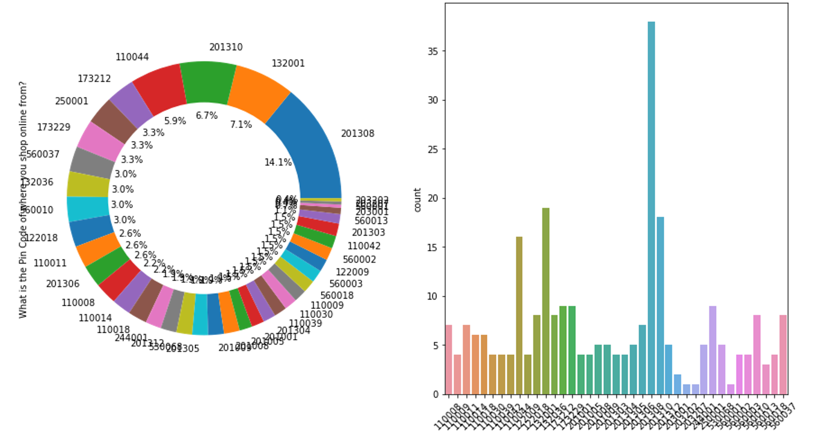

Univarient analysis of 'What is the Pin Code of where you shop online
from?' column.

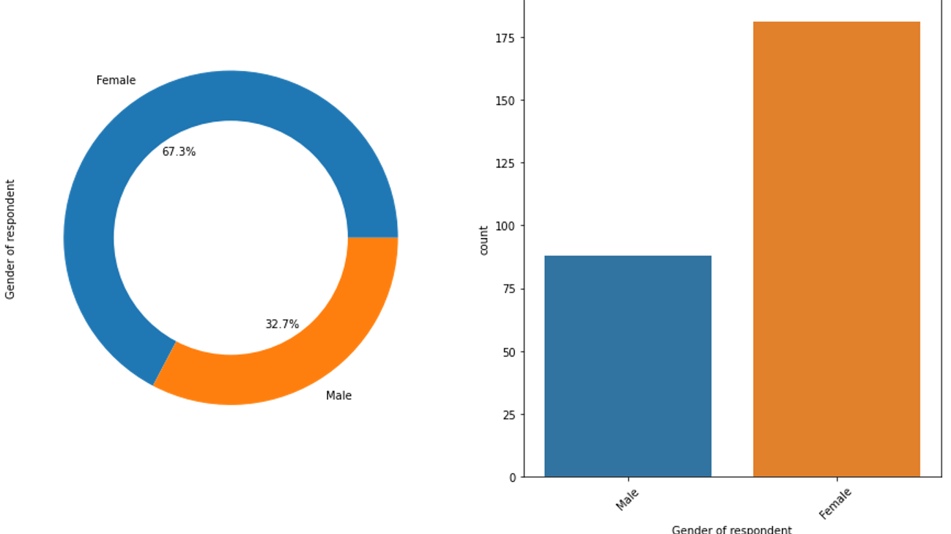

Univarient analysis of ‘Gender of respondent column.

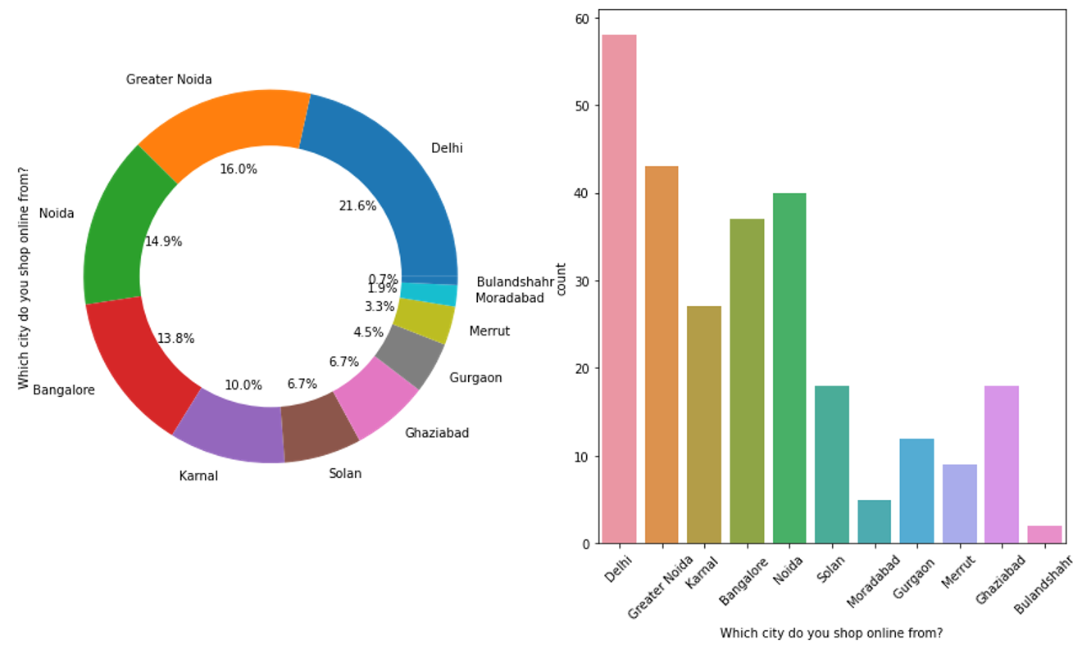
Univarient analysis of ‘Which city do you shop online from? column

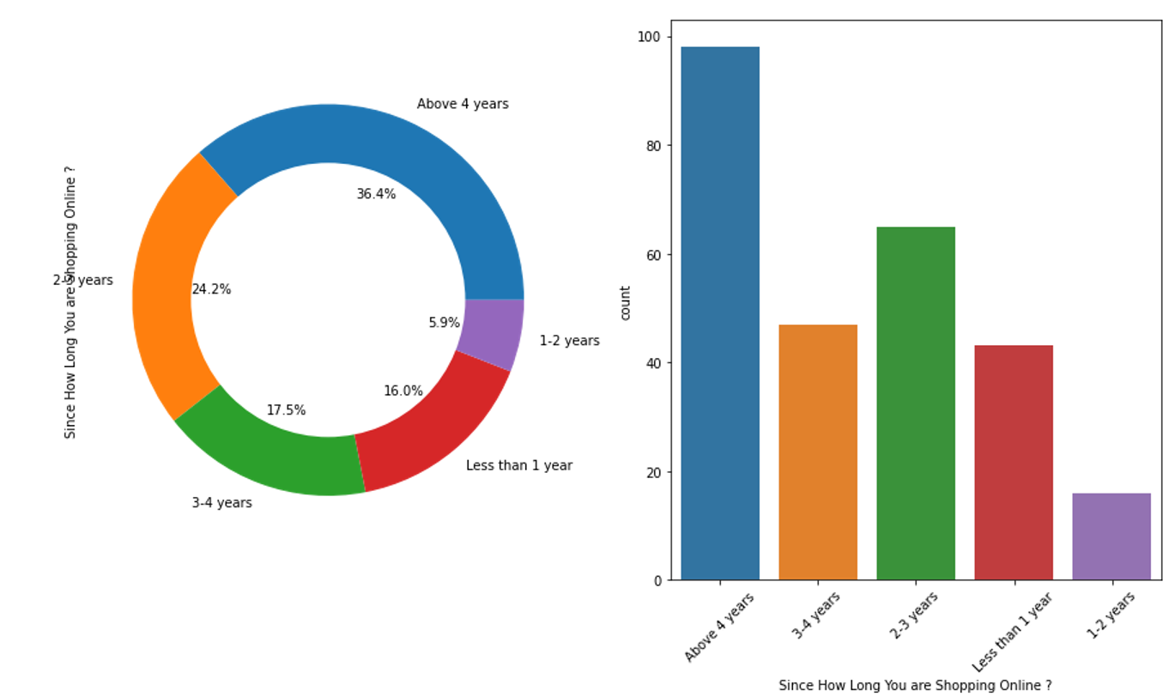
Univarient analysis of Since How Long You are Shopping Online?
Column.

Bi varient Analysis:

Scatter Plot
A scatter plot represents individual pieces of data using dots. These plots make it easier to see if two variables are related to each other. The resulting pattern indicates the type (linear or non-linear) and strength of the relationship between two variables.
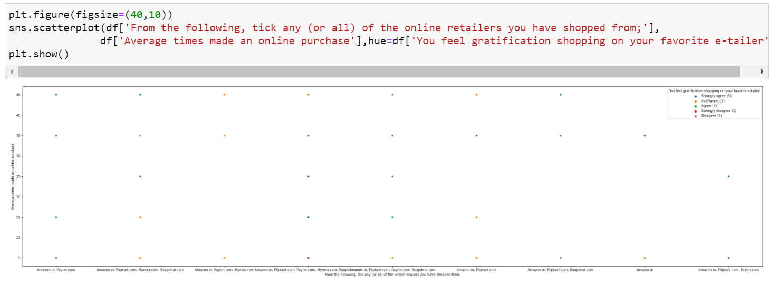
Here Above Scatterplot shows the comparison between two columns.
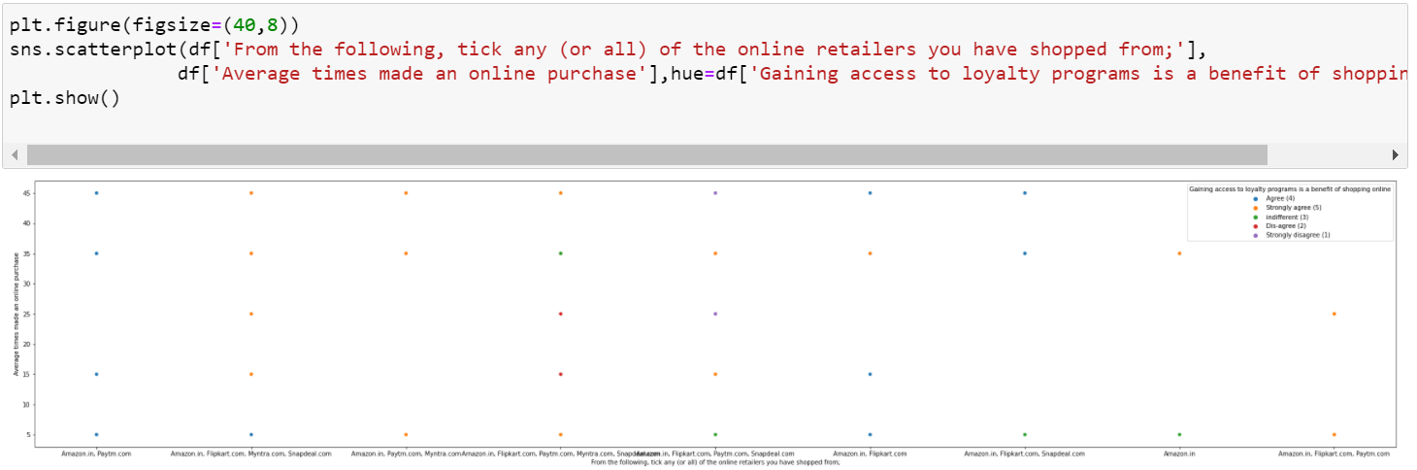
Here Above Scatterplot shows the comparison between two columns.
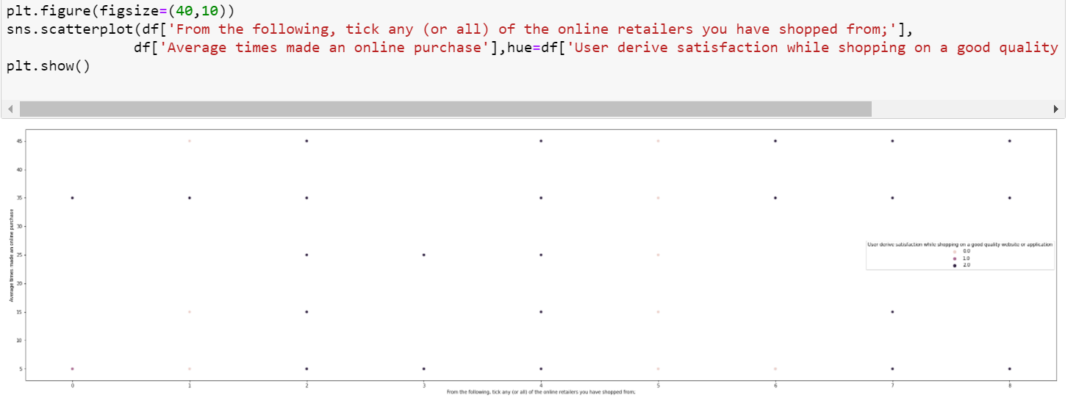
Here Above Scatterplot shows the comparison between two columns.

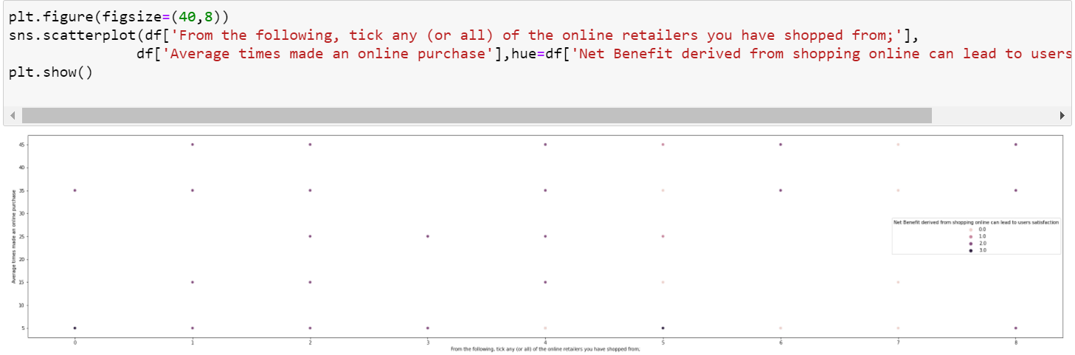
Here Above Scatterplot shows the comparison between two columns.
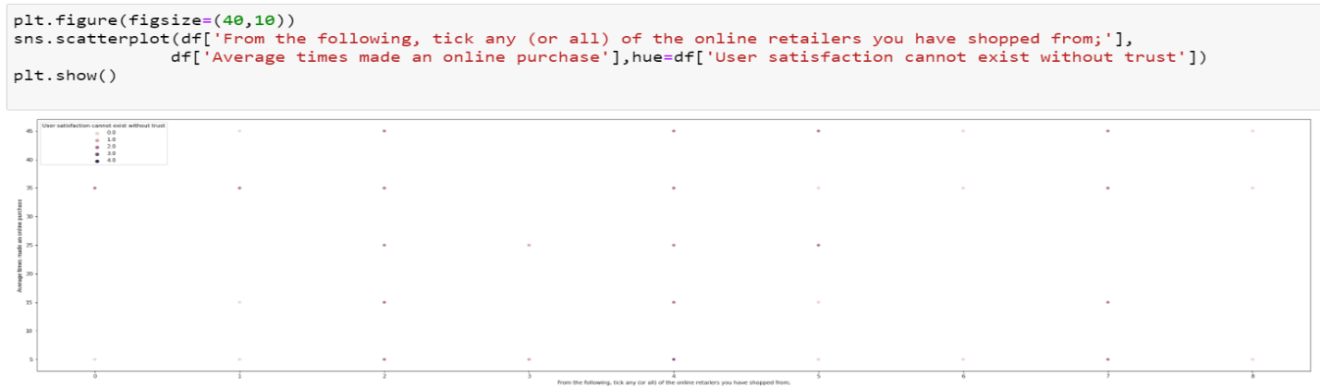
Here Above Scatterplot shows the comparison between two columns.
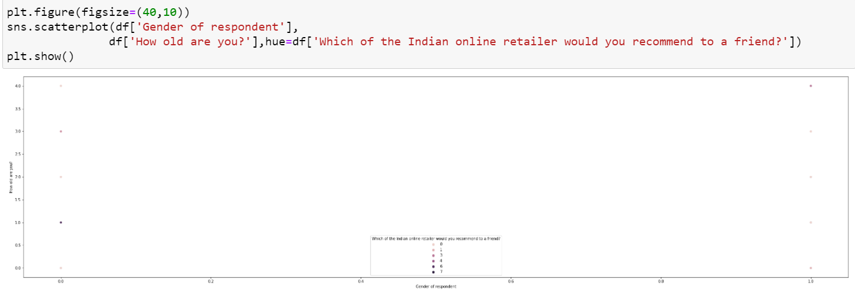
Here Above Scatterplot shows the comparison between two columns.

Multi Varien Analysis:
Multivariate analysis is used to study more complex sets of data than what univariate analysis methods can handle. ... Multivariate analysis can reduce the likelihood of Type errors. Sometimes, univariate analysis is preferred as multivariate techniques can result in difficulty interpreting the results of the test.

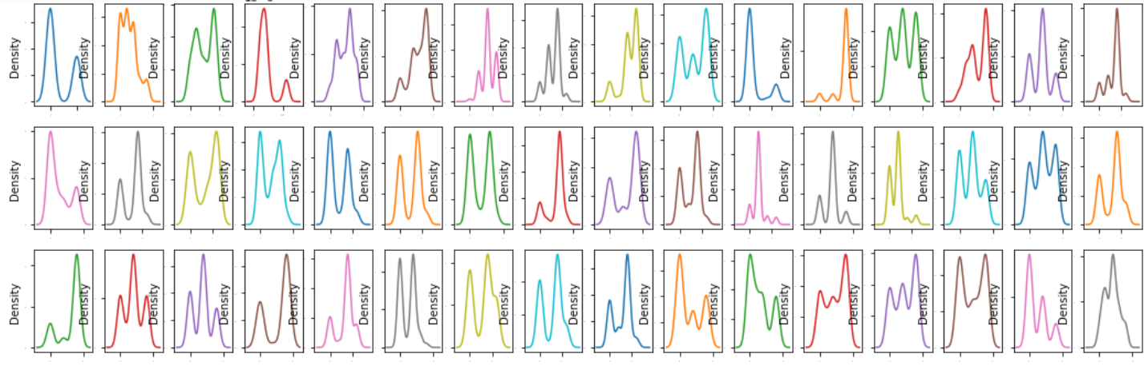
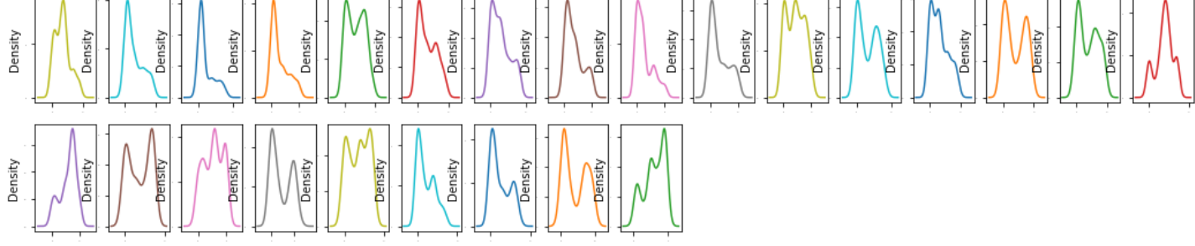

Histplot:
A histogram is a classic visualization tool that represents the.
A histogram provides a visual representation of the distribution of a dataset:
location, spread and skewness of the data; it also helps to visualize whether the
distribution is symmetric or skewed left or right. ... In brief, a histogram summarizes
the distribution properties of a continuous numerical variable.
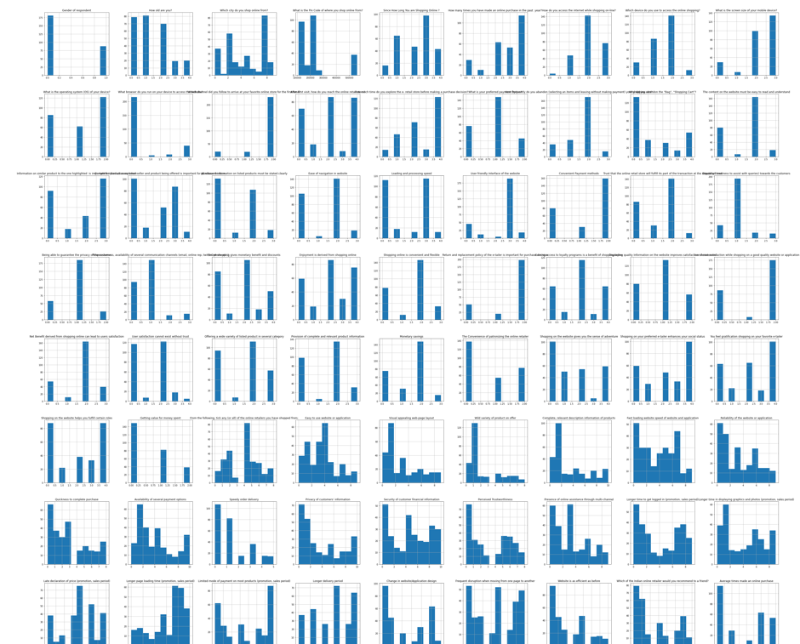
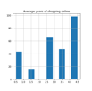

Checking Outliers:
An outlier is an object(s) that deviates significantly from the rest of the object collection. It is an abnormal observation during the Data Analysis stage, that data point lies far away from other values. An outlier is an observation that diverges from well-structured data.

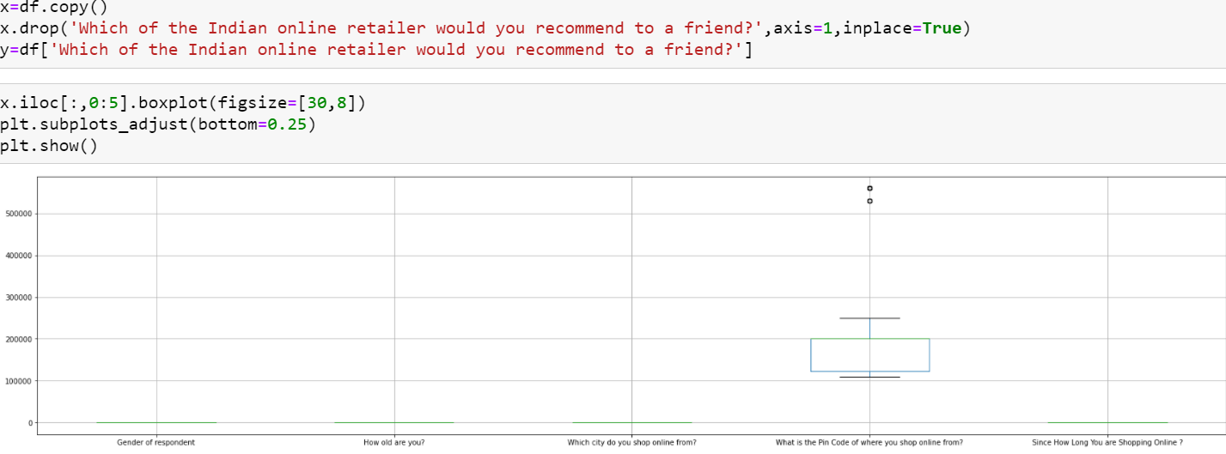
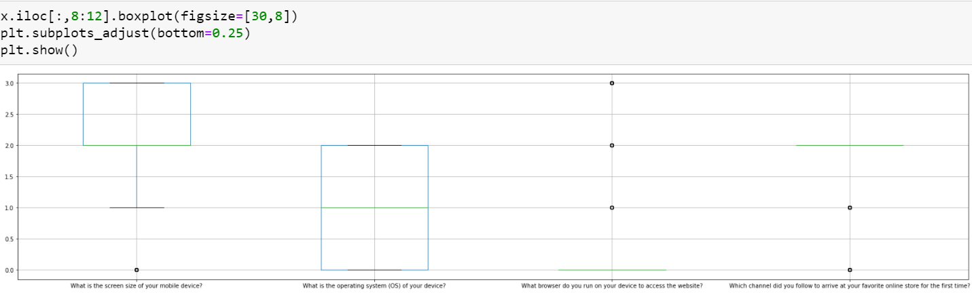
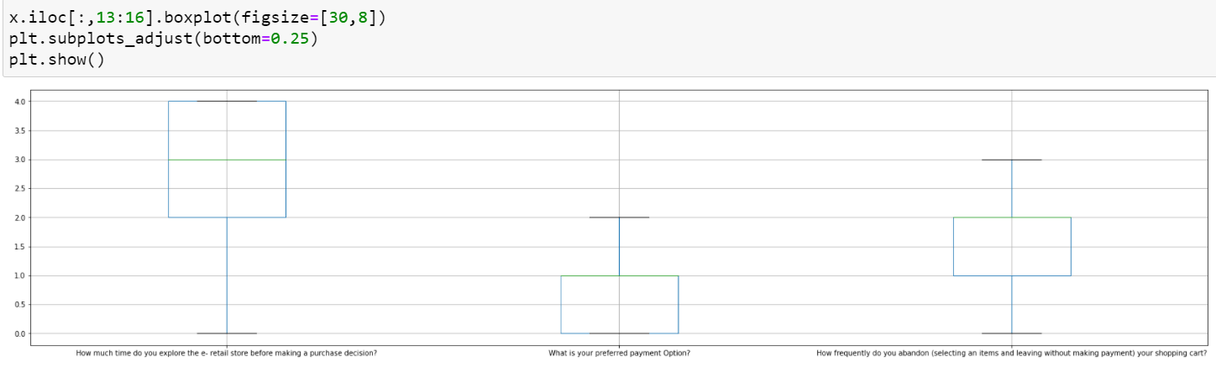
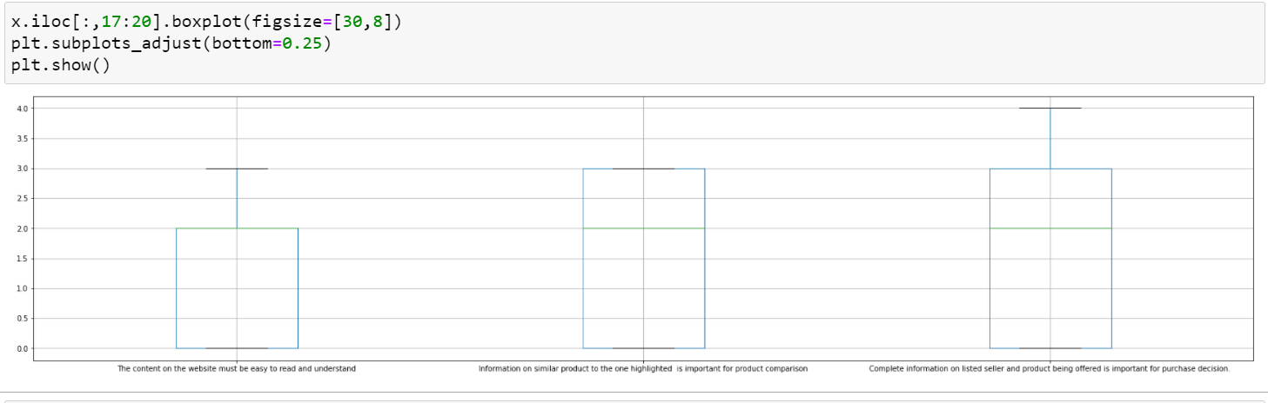
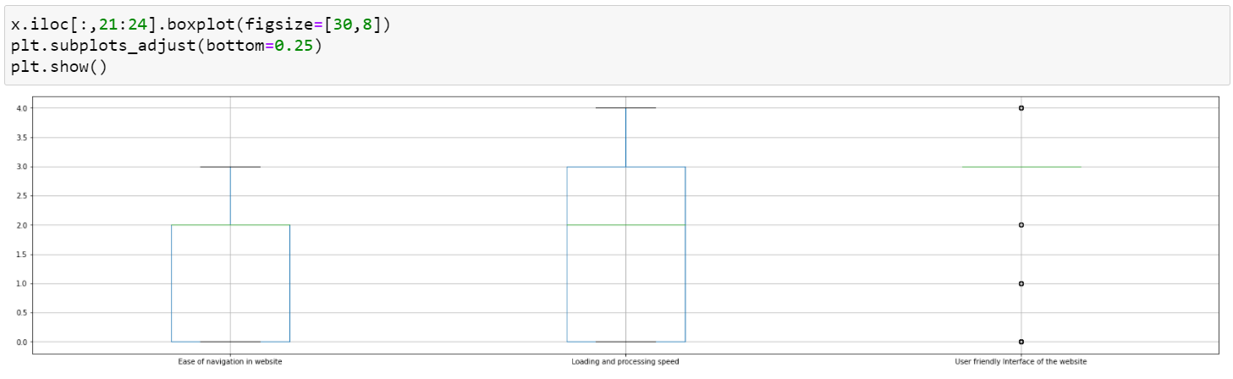
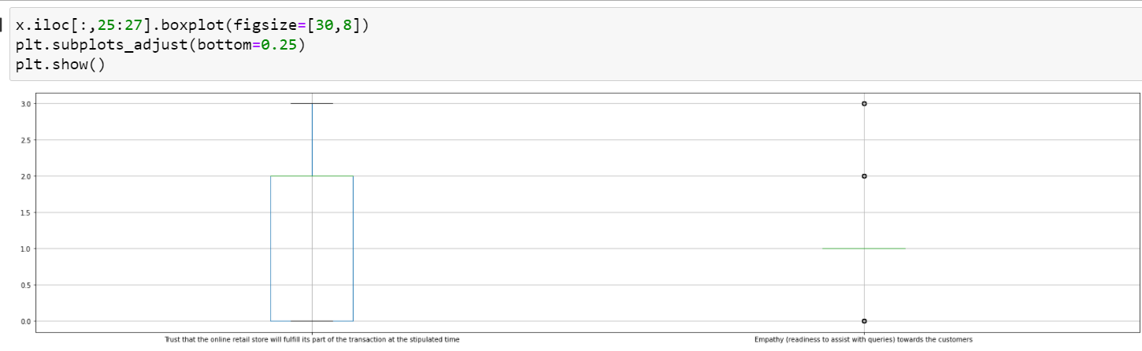
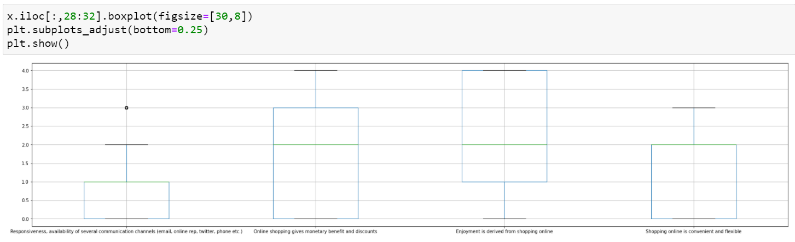
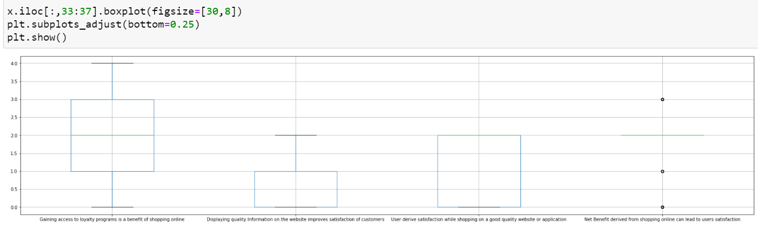

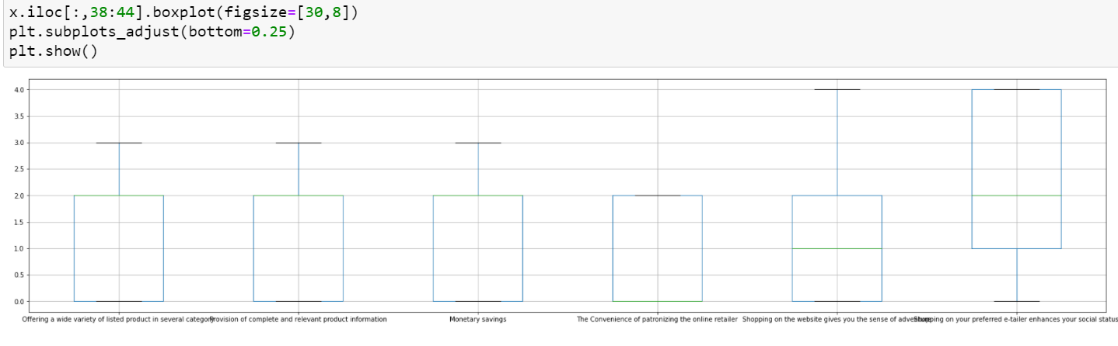
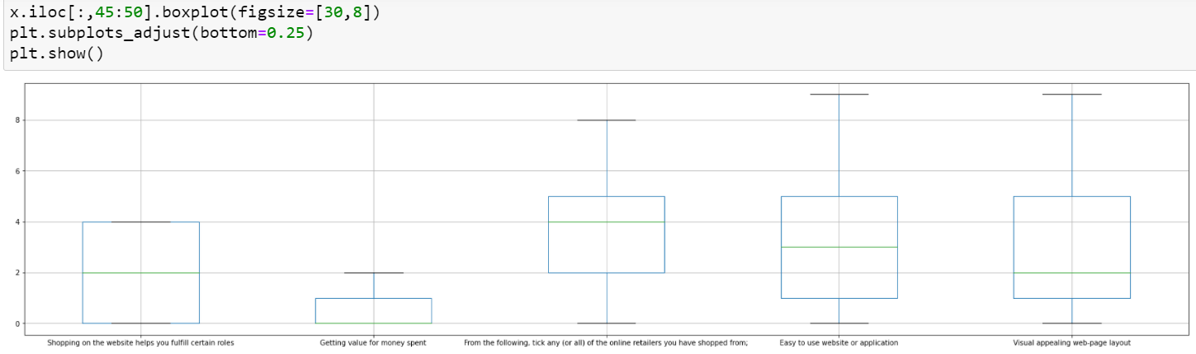
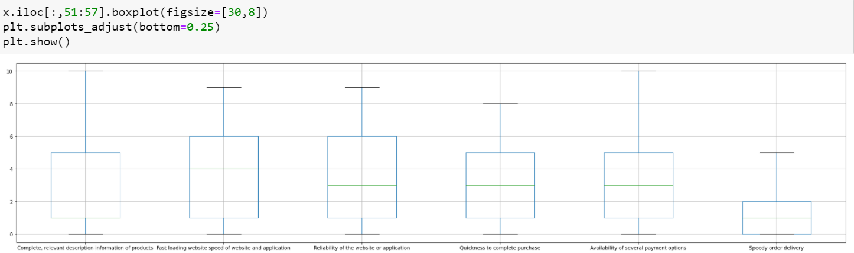
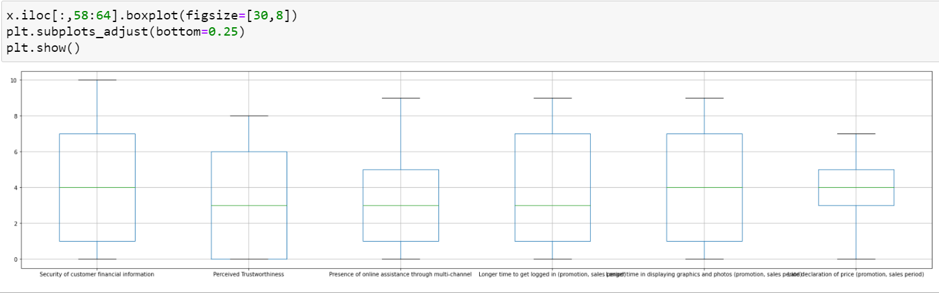

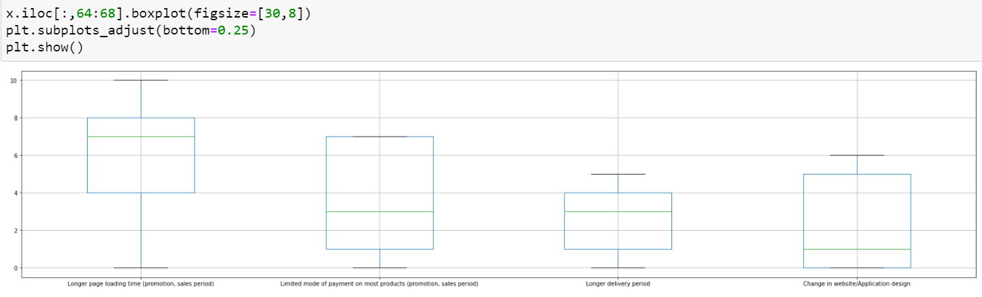
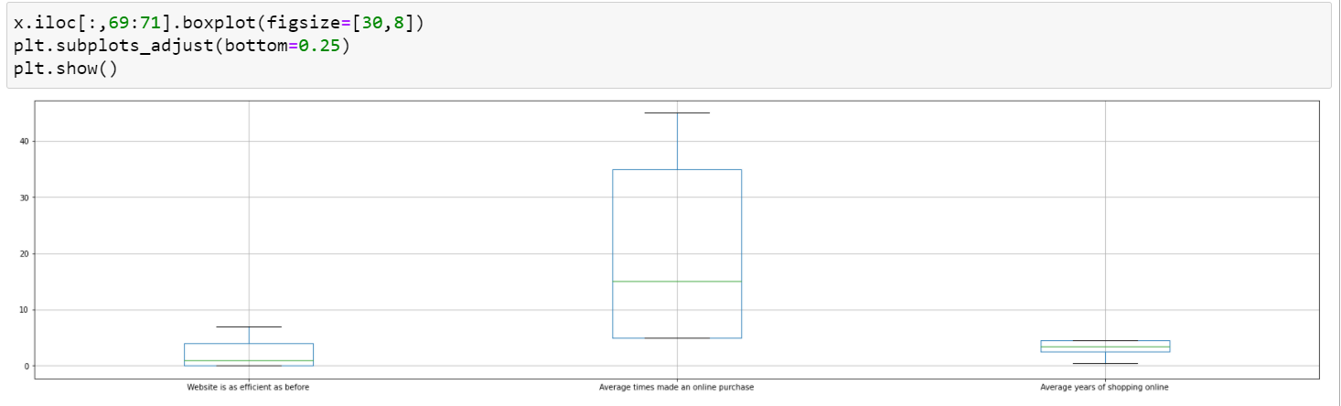
Here above many columns outlier was presents.
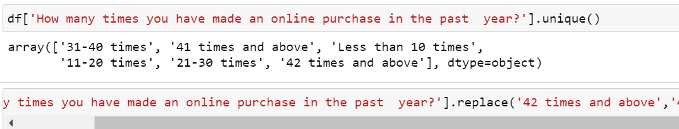
Here in above ‘How many times you have made an online purchase in the past 1 year?’ Column count the unique values and replace some unique values.

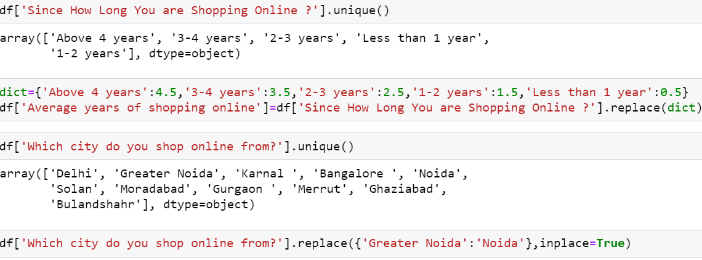

Here in above Since How Long You are Shopping Online ? in this Column replace the values with ‘Average years of shopping online’. And replace some values of ‘Which city do you shop online from?’ column.

Encoding:

Lable Encoder:

Label Encoding refers to converting the labels into a numeric form so as to convert them into the machine-readable form. Machine learning algorithms can then decide in a better way how those labels must be operated. It is an important pre-processing step for the structured dataset in supervised learning. Label Encoding is a popular encoding technique for handling categorical variables. In this technique, each label is assigned a unique integer based on alphabetical ordering.

Ordinal Encoder:

An ordinal encoding involves mapping each unique label to an integer value. This type of encoding is really only appropriate if there is a known relationship between the categories. This relationship does exist for some of the variables in our dataset, and ideally, this should be harnessed when preparing the data. In this case, we will ignore any possible existing ordinal relationship and assume all variables are categorical. It can still be helpful to use an ordinal encoding, at least as a point of reference with other encoding schemes. We can use the OrdinalEncoder from scikit-learn to encode each variable to integers. This is a flexible class and does allow the order of the categories to be specified as arguments if any such order is known.
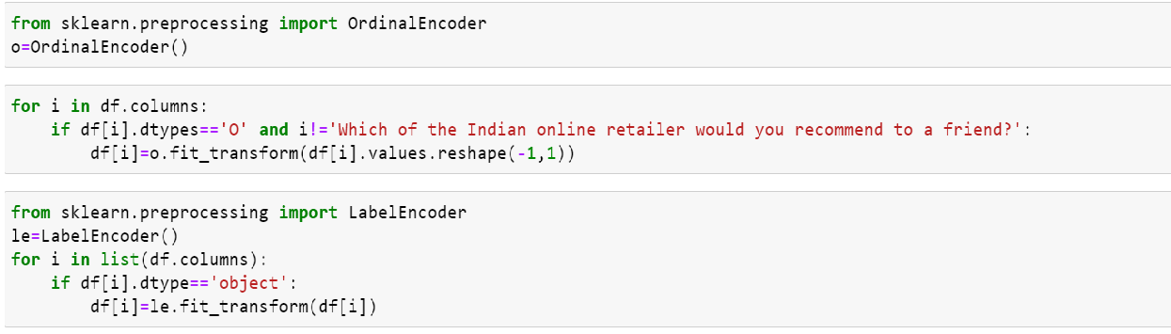
Here use Ordinal encoder and label encoder to replace the categorical values into numeric.

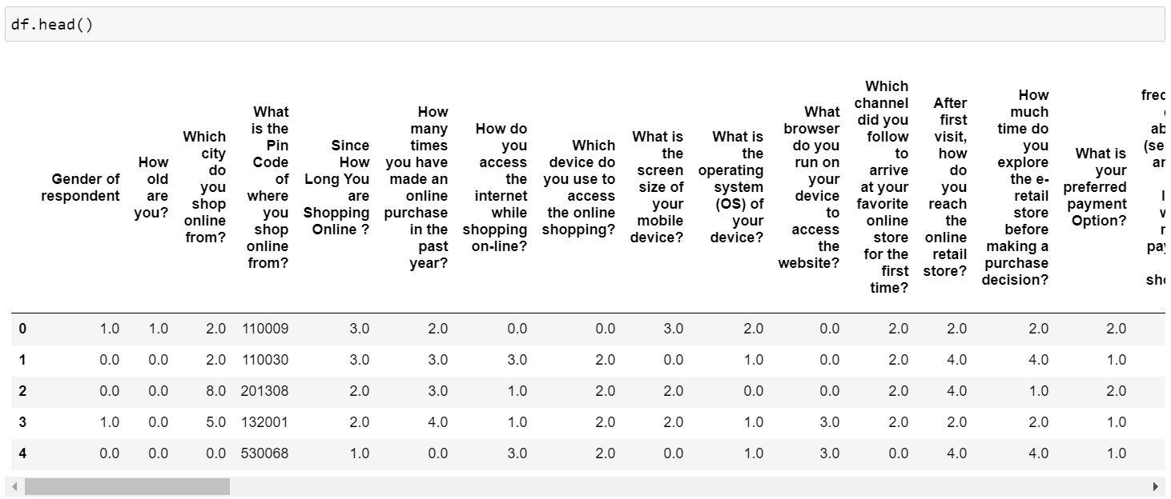
After converting categorical values into numeric using Lable encoder and Ordinal encoder then display dataset columns using df.head() here all all categorical values into numeric.

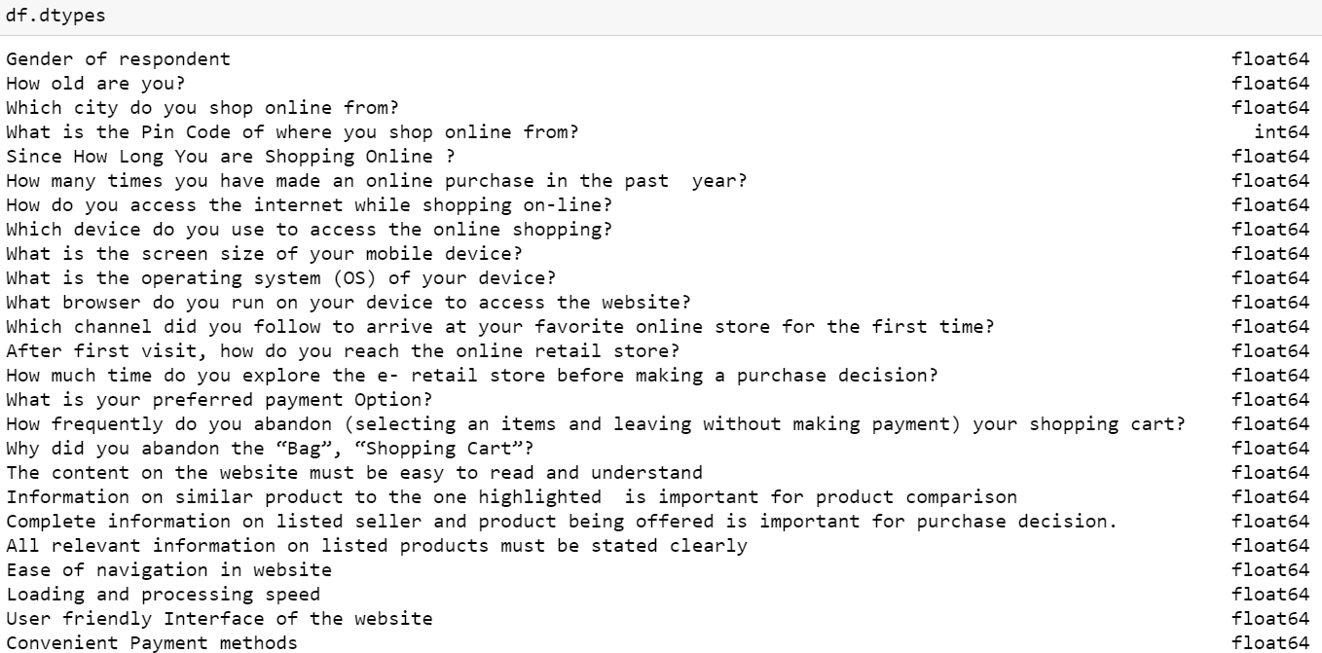
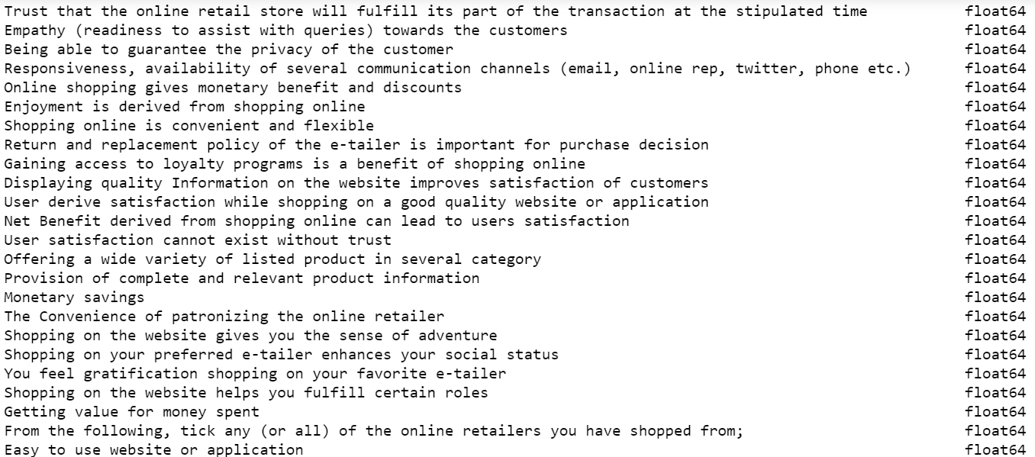
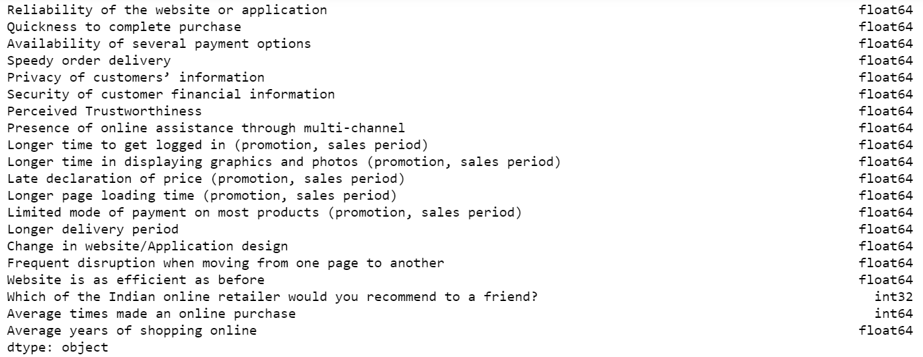

After converting categorical values into numeric check the data types of all the columns.

Correlation:
Correlation heatmap is graphical representation of correlation matrix representing correlation between different variables. The value of correlation can take any values from -1 to 1. ... Correlation between two variables can also be determined using scatter plot between these two variables.

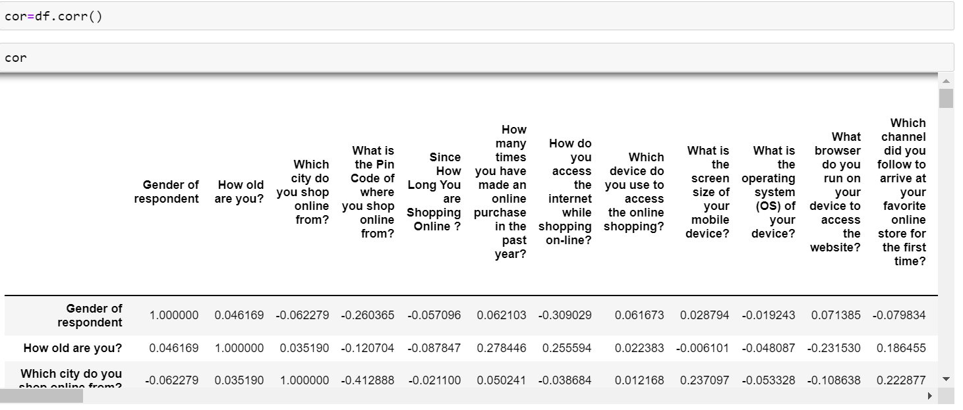
Check the correlation of all the columns in dataset.

HeatMap:

A heatmap is a graphical representation of data in which data values are represented as colors. That is, it uses color in order to communicate a value to the reader. This is a great tool to assist the audience towards the areas that matter the most when you have a large volume of data.

A heat map (or heatmap) is a data visualization technique that shows magnitude of a phenomenon as color in two dimensions. The variation in color may be by hue or intensity, giving obvious visual cues to the reader about how the phenomenon is clustered or varies over space. There are two fundamentally different categories of heat maps: the cluster heat map and the spatial heat map. In a cluster heat map, magnitudes are laid out into a matrix of fixed cell size whose rows and columns are discrete phenomena and categories, and the sorting of rows and columns is intentional and somewhat arbitrary, with the goal of suggesting clusters or portraying them as discovered via statistical analysis. The size of the cell is arbitrary but large enough to be clearly visible. By contrast, the position of a magnitude in a spatial heat map is forced by the location of the magnitude in that space, and there is no notion of cells; the phenomenon is considered to vary continuously.

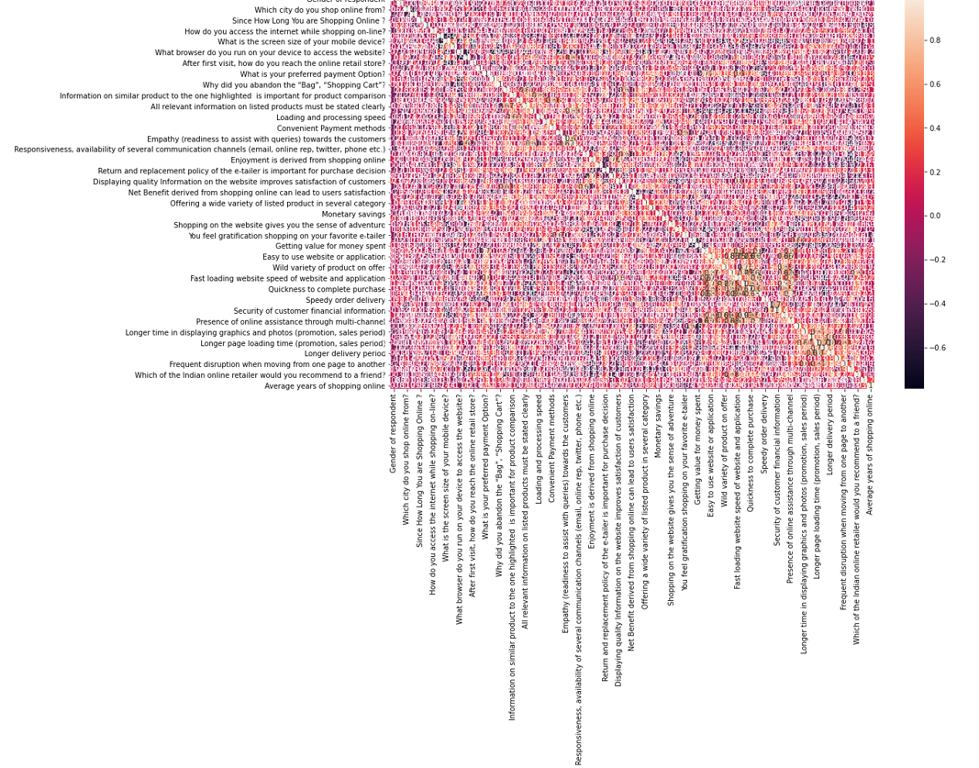
In above heat map shows the correlation of all the independent variable with target variable.

zScore:

Simply put, a z-score (also called a standard score) gives you an idea of how far from the mean a data point is. But more technically it's a measure of how many standard deviations below or above the population mean a raw score is. A z-score can be placed on a normal distribution curve.
Take your data point, subtract the mean from the data point, and then divide by your standard deviation. That gives you your Z-score. You can use Z-Score to determine outliers.One of the most commonly used tools in determining outliers is the Z-score. Z-score is just the number of standard deviations away from the mean that a certain data point is.
In your future data science life, Z-scores are gonna be a really useful way to think about how usual or how unusual a certain data point is. And that’s going to be really valuable once we start making inferences based on our data. In this story, we will take a deep dive into our notebooks and learn how to detect outliers using Z-Score
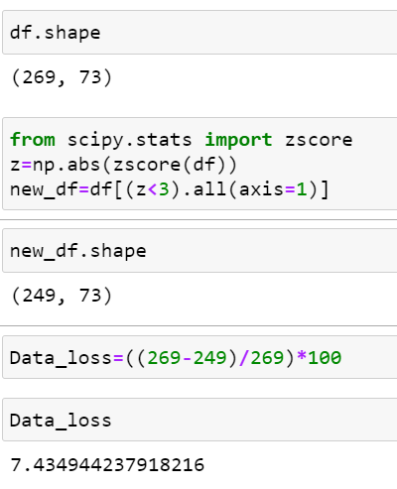

Using Zscore 7.43 dataloss
Use IQR Check the dataloss:

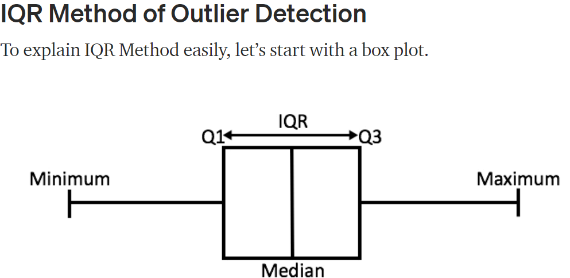
A box plot tells us, more or less, about the distribution of the data. It gives a sense of how much the data is actually spread about, what’s its range, and about its skewness. As you might have noticed in the figure, that a box plot enables us to draw inference from it for an ordered data, i.e., it tells us about the various metrics of a data arranged in ascending order.
In the above figure,
- minimum is the minimum value in the dataset,
- and maximum is the maximum value in the dataset.
So the difference between the two tells us about the range of dataset.
- The median is the median (or centre point), also called second quartile, of the data (resulting from the fact that the data is ordered).
- Q1 is the first quartile of the data, i.e., to say 25% of the data lies between minimum and Q1.
- Q3 is the third quartile of the data, i.e., to say 75% of the data lies between minimum and Q3.
The difference between Q3 and Q1 is called the Inter-Quartile Range or IQR.
IQR = Q3 - Q1
To detect the outliers using this method, we define a new range, let’s call it decision range, and any data point lying outside this range is considered as outlier and is accordingly dealt with. The interquartile range shows how the data is spread about the median. It is less susceptible than the range to outliers and can, therefore, be more helpful.

Using the Interquartile Rule to Find Outliers
Though it's not often affected much by them, the interquartile range can be used to detect outliers. This is done using these steps:
- Calculate the interquartile range for the data.
- Multiply the interquartile range (IQR) by 1.5 (a constant used to discern outliers).
- Add 1.5 x (IQR) to the third quartile. Any number greater than this is a suspected outlier.
- Subtract 1.5 x (IQR) from the first quartile. Any number less than this is a suspected outlier.
Remember that the interquartile rule is only a rule of thumb that generally holds but does not apply to every case. In general, you should always follow up your outlier analysis by studying the resulting outliers to see if they make sense. Any potential outlier obtained by the interquartile method should be examined in the context of the entire set of data.

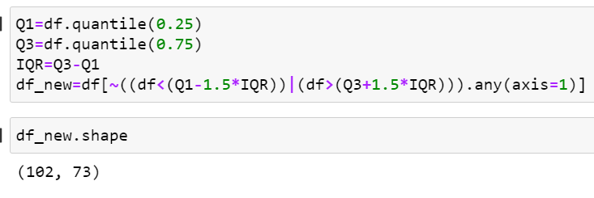
Using IQR more dataloss.

Checking Skewness:

The skewness is a measure of symmetry or asymmetry of data distribution, and kurtosis measures whether data is heavy-tailed or light-tailed in a normal distribution. Data can be positive-skewed (data-pushed towards the right side) or negative-skewed (data-pushed towards the left side).
Skewness is the measure of the asymmetry of an ideally symmetric probability distribution and is given by the third standardized moment. If that sounds way too complex, don’t worry! Let me break it down for you.
In simple words, skewness is the measure of how much the probability distribution of a random variable deviates from the normal distribution.
Now, you might be thinking – why am I talking about normal distribution here?
Well, the normal distribution is the probability distribution without any skewness. You can look at the image below which shows symmetrical distribution that’s basically a normal distribution and you can see that it is symmetrical on both sides of the dashed line. Apart from this, there are two types of skewness:
- Positive Skewness
- Negative Skewness

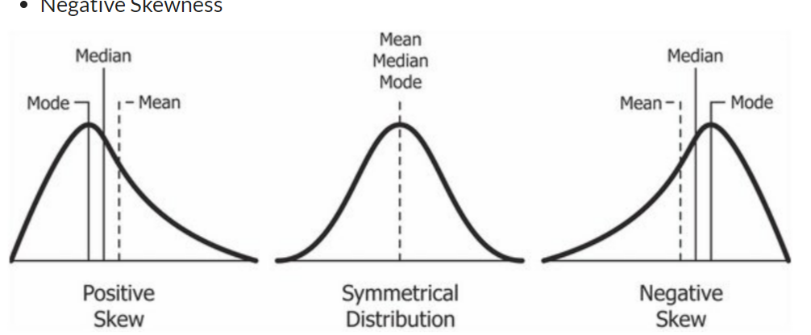
The probability distribution with its tail on the right side is a positively skewed distribution and the one with its tail on the left side is a negatively skewed distribution. If you’re finding the above figures confusing, that’s alright. We’ll understand this in more detail later. Before that, let’s understand why skewness is such an important concept for you as a data science prof essional.

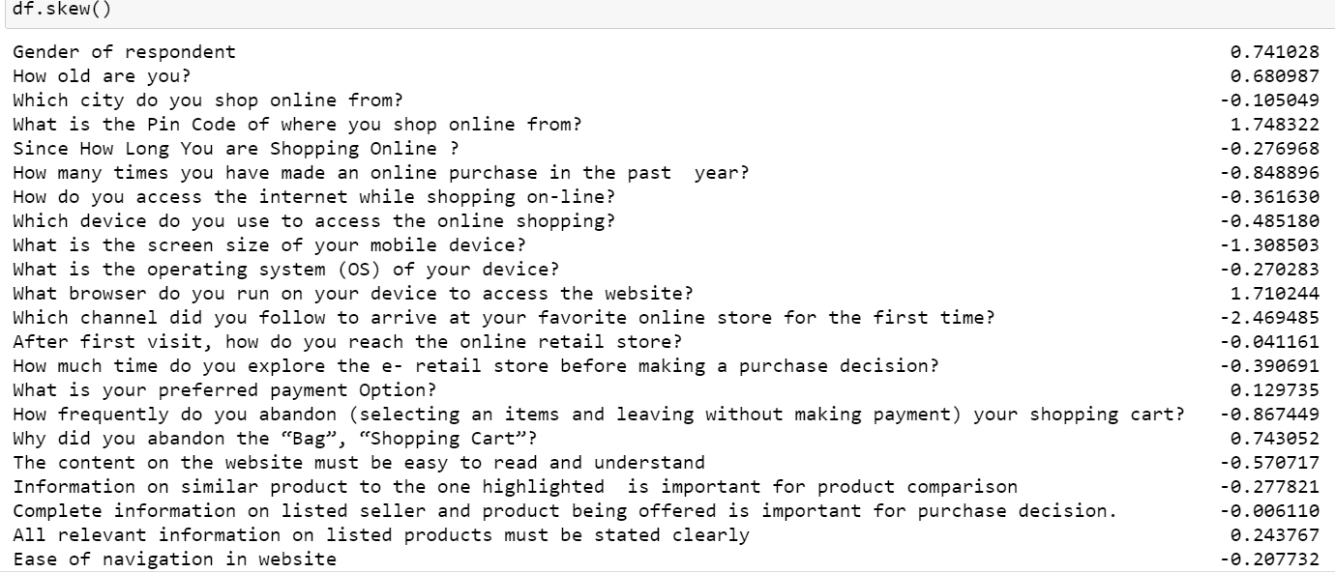

Here we check the skewness using df.skew() using this skewness is present many columns
How to remove skewness:
Since you know how much the skewed data can affect our machine learning model’s predicting capabilities, it is better to transform the skewed data to normally distributed data. Here are some of the ways you can transform your skewed data:
- Power Transformation
- Log Transformation
- Exponential Transformation
Here we use Power Transformation to remove skewness:
Power Transformation :
Power transforms are a family of parametric, monotonic transformations that are applied to make data more Gaussian-like. This is useful for modeling issues related to heteroscedasticity (non-constant variance), or other situations where normality is desired.
Currently, PowerTransformer supports the Box-Cox transform and the Yeo-Johnson transform. The optimal parameter for stabilizing variance and minimizing skewness is estimated through maximum likelihood.
Box-Cox requires input data to be strictly positive, while Yeo-Johnson supports both positive or negative data.
By default, zero-mean, unit-variance normalization is applied to the transformed data.
log transformation and index changing in python:
- Apply log to each column variable.
- Name this newly generated variable, "log_variable". ...
- Do log(variable_value +1) for values in df[variables] columns that are zero or missing, to avoid getting "-inf" returned.
- Find index of original variable.

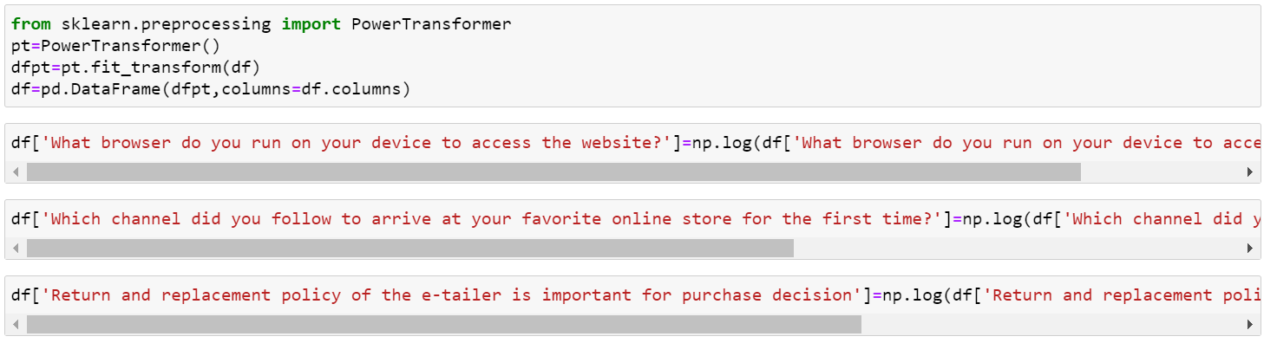

After use Power transform and log transform there was no skewness is present in dataset.

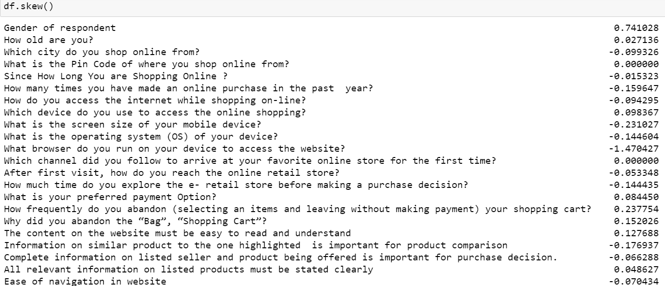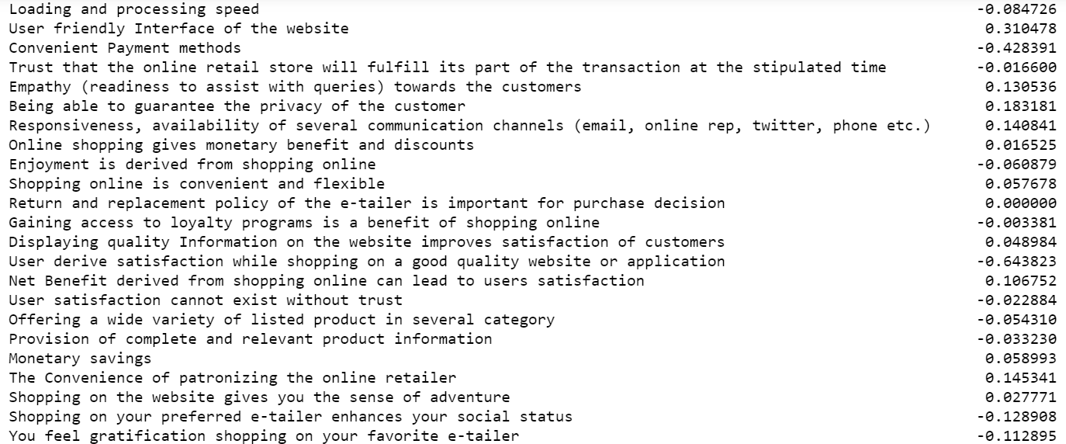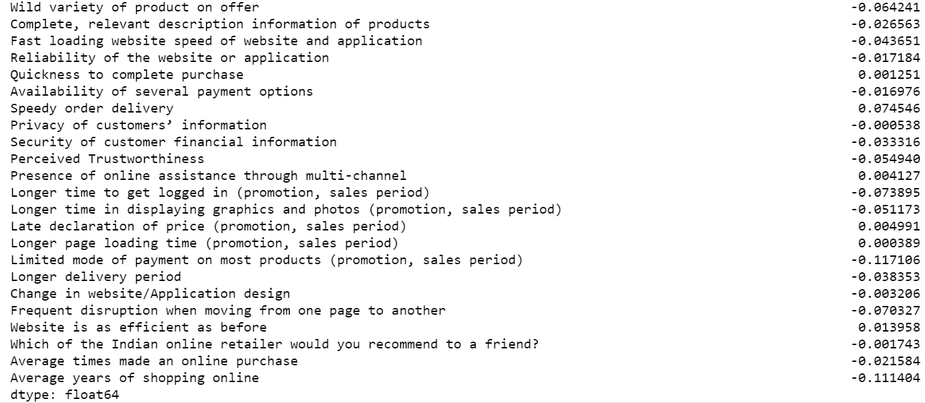
After using Power transform and log transform check the skewness there was no skewness is present indataset.

Oversamplig:
SMOTE:
SMOTE is an oversampling technique where the synthetic samples are generated for the minority class. This algorithm helps to overcome the overfitting problem posed by random oversampling. It focuses on the feature space to generate new instances with the help of interpolation between the positive instances that lie together.
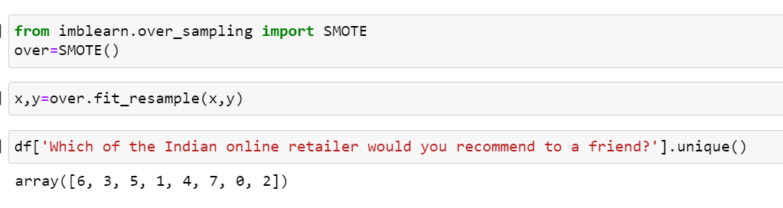
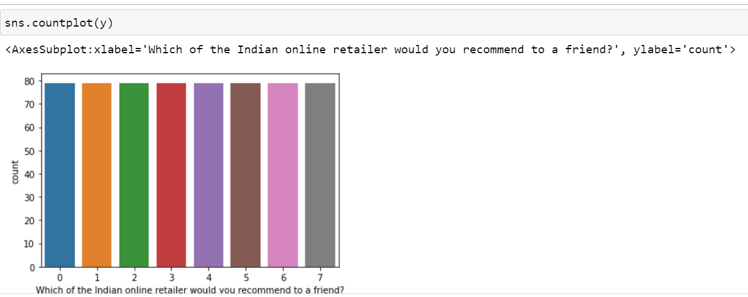
After using Oversampling SMOTE now class are balance.
MinMax Scaler Technique:
Here use MinMaxScaler Techique. The MinMax scaler is one of the simplest scalers to understand. It just scales all the data between 0 and 1.

5.Building Machine Learning Models:
Now we will several Machine Learning models and compare their results. Note that because the dataset does not provide labels for their dataset we need to use the predictions on the dataset to compare the algorithms with each other. Later on, we will use cross validation.

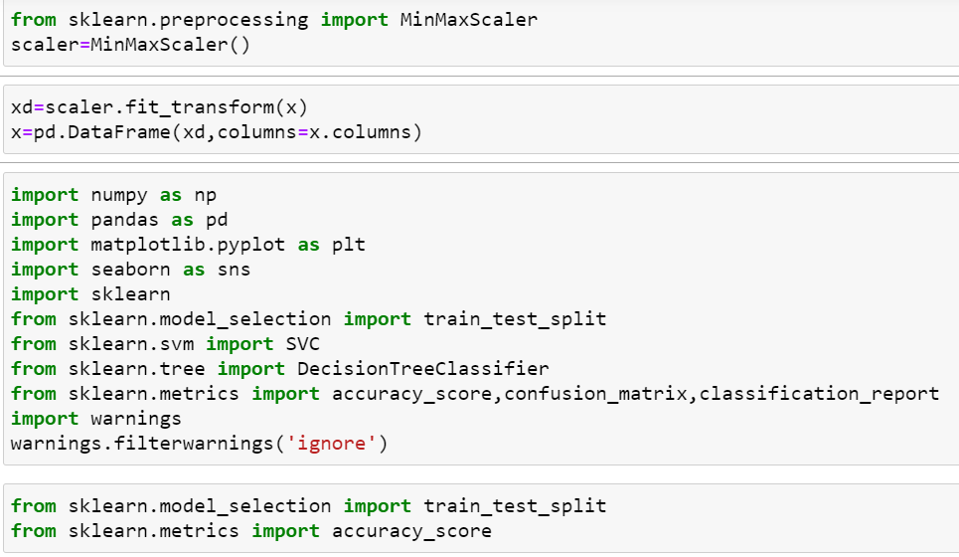
Loading different library which are necessary.

Decision Tree Classifier:
Decision Tree is a Supervised learning technique that can be used for both classification and Regression problems, but mostly it is preferred for solving Classification problems. It is a tree-structured classifier, where internal nodes represent the features of a dataset, branches represent the decision rules and each leaf node represents the outcomes In a Decision tree, there are two nodes, which are the Decision Node and Leaf Node. Decision nodes are used to make any decision and have multiple branches, whereas Leaf nodes are the output of those decisions and do not contain any further branches.
The decisions or the test are performed on the basis of features of the given dataset.
It is a graphical representation for getting all the possible solutions to a problem/decision based on given conditions.
It is called a decision tree because, similar to a tree, it starts with the root node, which expands on further branches and constructs a tree-like structure.
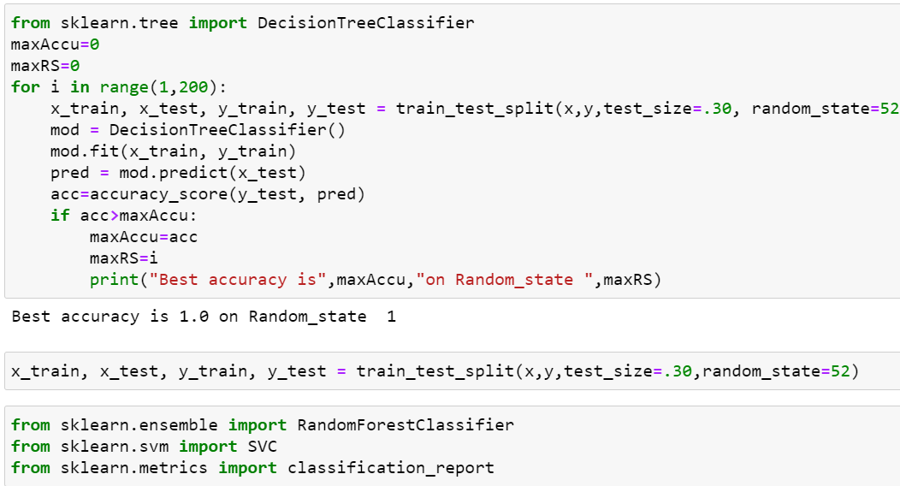

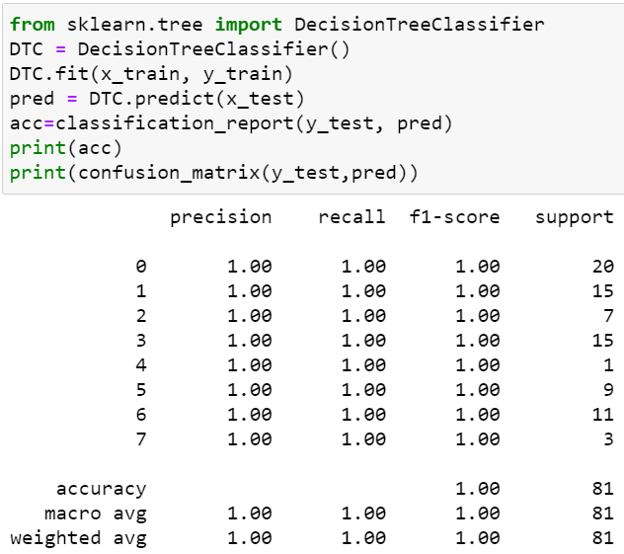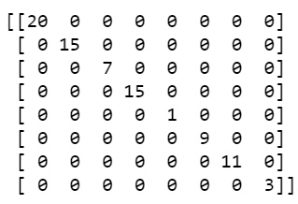
Here we use decision tree classifier model check accuracy score and confusion matrix of above accuracy score is 1.0.

Random Forest Classifier:
What is a Random Forest Classifier? The term “Random Forest Classifier” refers to the classification algorithm made up of several decision trees. The algorithm uses randomness to build each individual tree to promote uncorrelated forests, which then uses the forest's predictive powers to make accurate decisions.

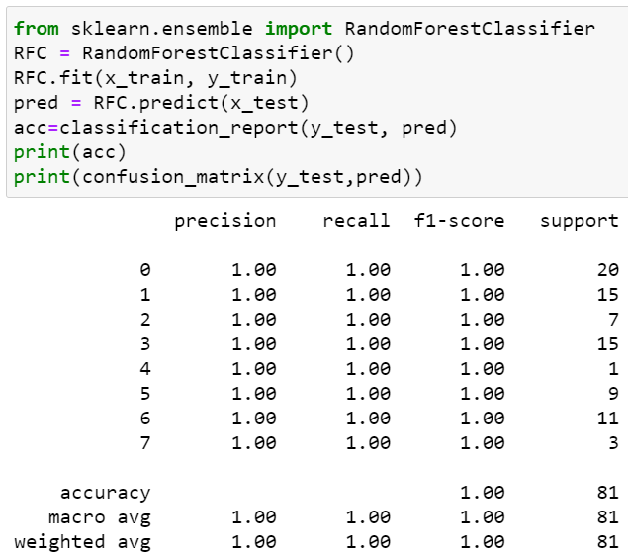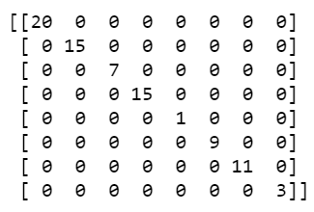
Here we use Random Forest classifier model check accuracy score and confusion matrix of above accuracy score is 1.0.

AdaBoost Classifier:

AdaBoost (Adaptive Boosting) is a very popular boosting technique that aims at combining multiple weak classifiers to build one strong classifier. ... The classifier mentioned here could be any of your basic classifiers, from Decision Trees (often the default) to Logistic Regression, etc.

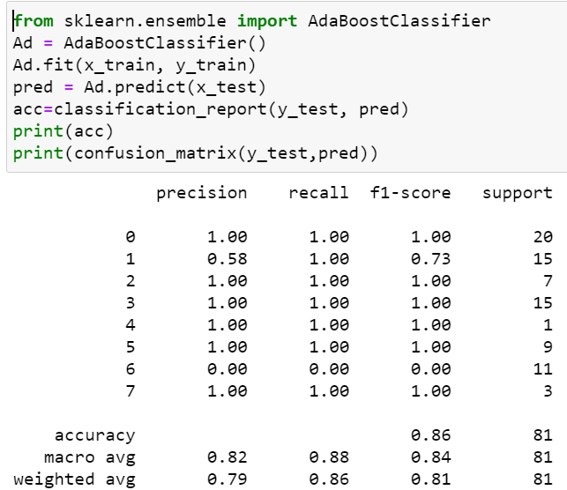
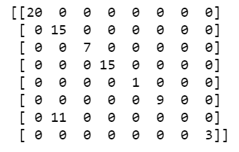
Here we use Random Forest classifier model check accuracy score and confusion matrix of above accuracy score is 0.86.

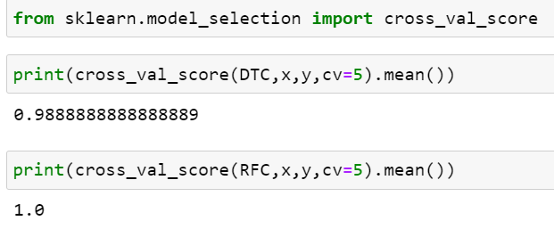
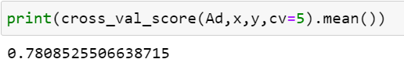
Here we check accuracy score and after that check cross validation score of all the model the Random forest classifier is the best model because accuracy score and cross validation score is 1.0 So apply hyper parameter tuning on it.

GridSearchCv:
GridSearchCV is a library function that is a member of sklearn's model_selection package. It helps to loop through predefined hyperparameters and fit your estimator (model) on your training set. So, in the end, you can select the best parameters from the listed hyperparameters.

Parameterlist:
There is a list of different machine learning models. They all are different in some way or the other, but what makes them different is nothing but input parameters for the model. These input parameters are named as Hyperparameters. These hyperparameters will define the architecture of the model, and the best part about these is that you get a choice to select these for your model. Of course, you must select from a specific list of hyperparameters for a given model as it varies from model to model.
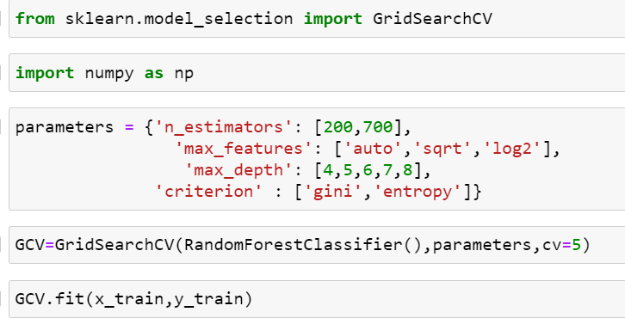
Here above are the parameter list of RandomForestClassifier model .
The above code block we have the following parameters:.
max_features: In this maximum features there are two values auto and log2,sqrt.
Criterion: In criterion there are two parameter values are present gini and entropy and n_estimator is 200 ,700 and in max_depth 4,5,6,7,8.

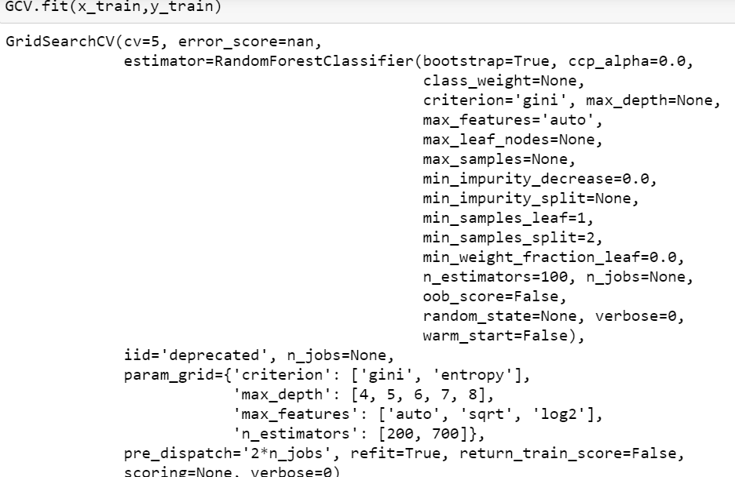
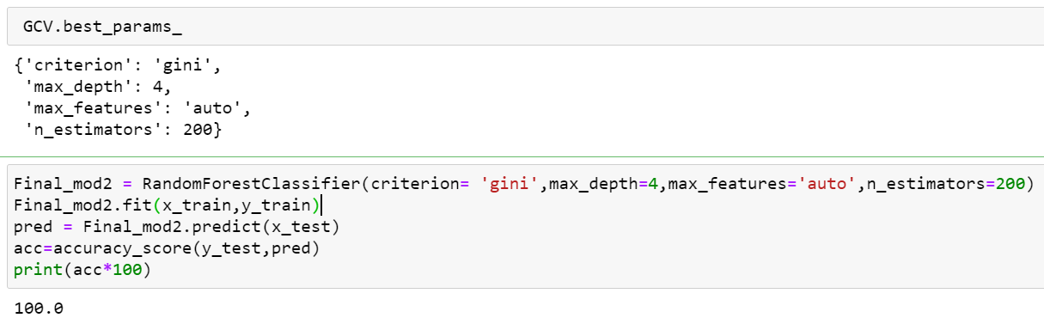
Here after use different parameter list the best parameter list is select.
Above are the best parameter list RandomForestClassifier.
Put this parameters into the model so output is finally best score os RandomForestClassifier is 100 so it is the best score.

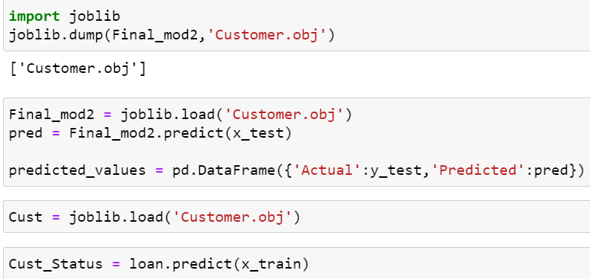
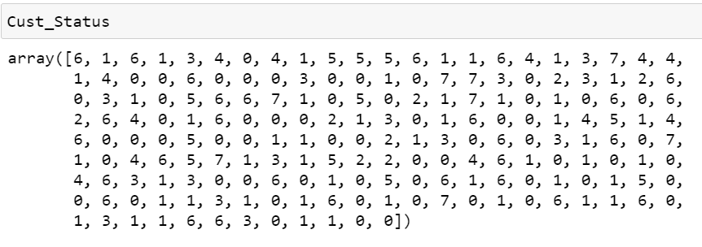
Finally load the model and predict the values.

6.Conclusion:

In this customer retention project Marketers can use the identified segments of online customers on the basis of their shopping values and decide accordingly on marketing strategies. Because customers satisfaction is most important.

